Q1 not examinable.

Q2.a) i)

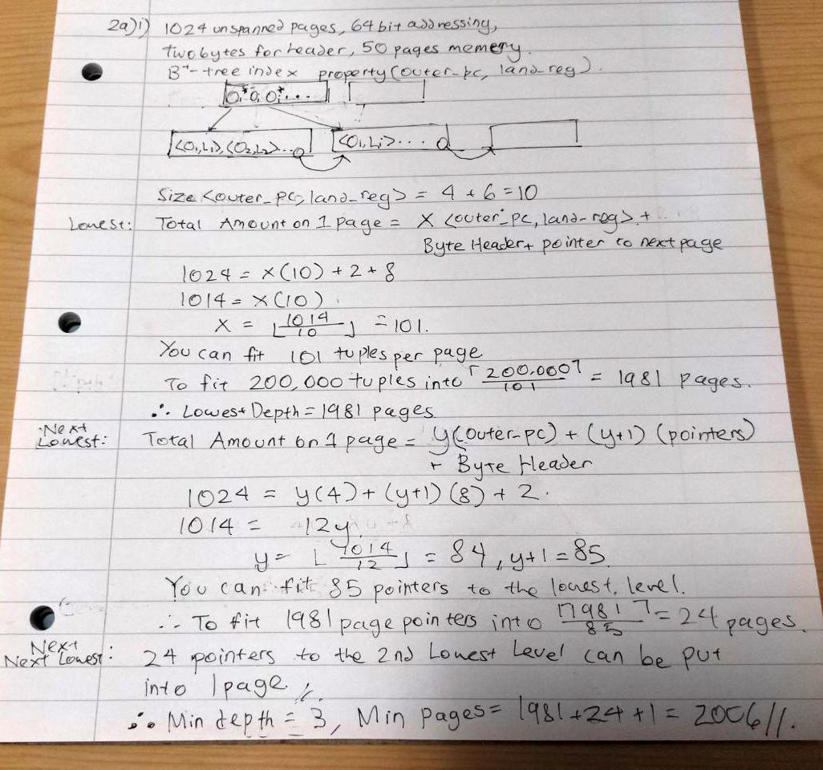

a) ii)

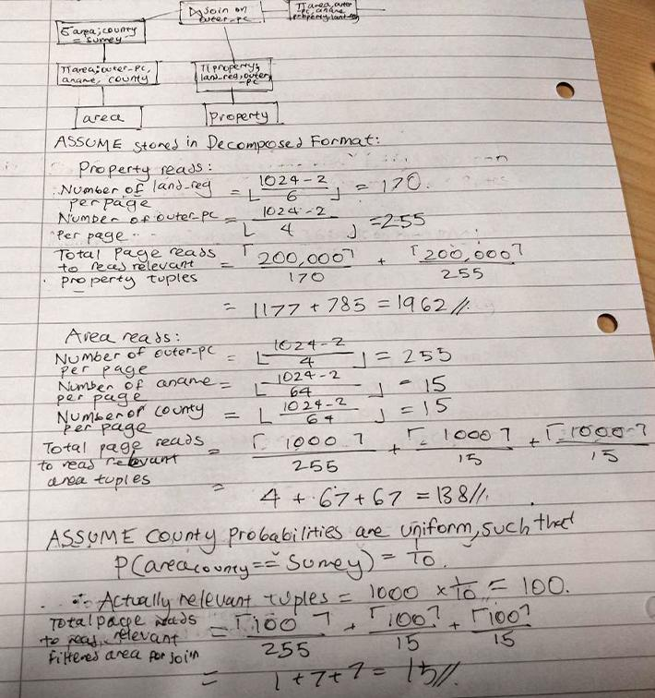

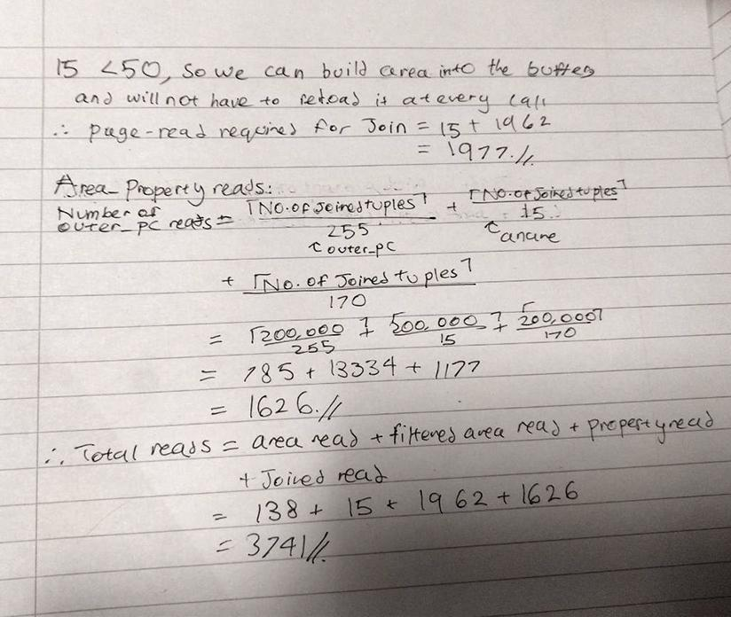

a) iii)

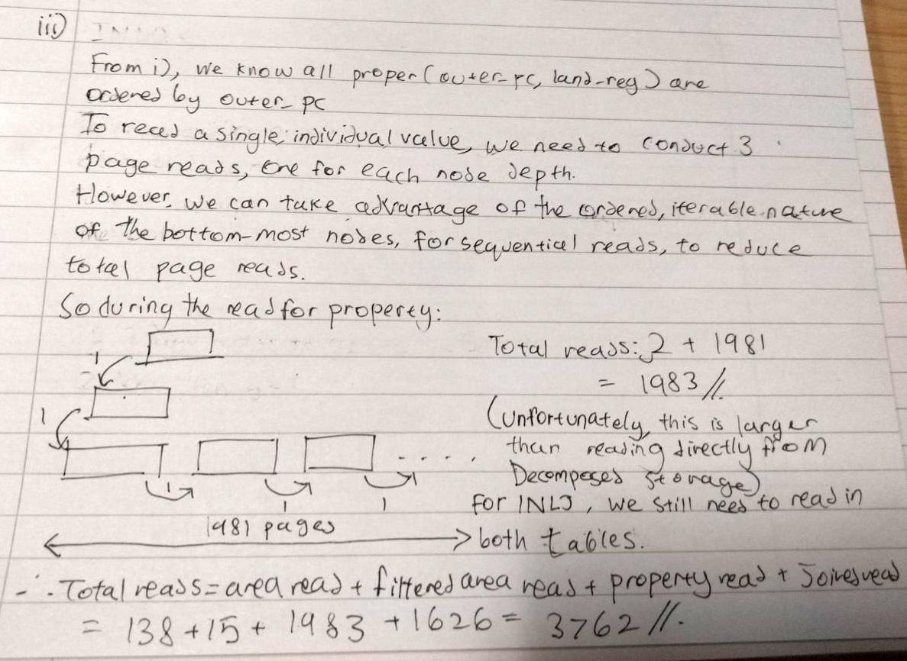

a)iv)  
Same as our Buffered BNLJ, 3741

bi)

Not CSR

Anomaly: Lost Update as w2 is using old read data

Recoverable

??????

**Anomalies**

Lost Update: r_2[a_sw19] < w_1[a_sw19] < w_2[a_sw19]

Dirty Write: w_1[a_sw19] < w_2[a_sw19] < c_1

**Conflicts**

4 in total

When constructing the SG there’s a cycle therefore not CSR. For recoverability, the commit order is “C1 < C2” which is not met by all conflicts, therefore not recoverable.

ii)

CSR (w3[ae8] -> r2[ae8])

~~Anomaly: Dirty Reads as c3 is committing before c2~~

None of them

?????

No anomalies or conflicts, therefore CSR and recoverable

3) a) Companies that have no leases, but have telephone numbers, return cno, cname and telephone number count

Not absolutely sure of the answer so take it with a pinch of salt

Company_and_lease =

JOIN company BY cno LEFT,

lease by cno;

Company_without_lease =

FILTER company_and_lease

BY lease::cno IS NULL;

Company_cno_cname_without_lease =

FOREACH company_without_lease

GENERATE cno, cname;

Company_and_numbers =

JOIN Company_cno_cname_without_lease BY cno LEFT,

Telephone BY cno;

Company_number_groups =

GROUP company_and_numbers BY cno;

Company_and_number_counts =

FOREACH Company_number_groups

GENERATE group AS cno,

COUNT(telephone.number) AS no_telephone;

Company_with_numbers =

FILTER Company_and_number_counts

BY no_telephone > 0;

Cno_cname =

FOREACH company

GENERATE cno, cname, no_telephone

b) i)

Since we are dealing with between ‘S’ and ‘TZ99’, we send our queries to sites 2 and 4

LTM2:

SELECT rates, agent, outer_pc

INTO ltm2

FROM property

WHERE outer_pc BETWEEN ‘S’ AND ‘TZ99’

LTM4:

SELECT outer_pc, county

INTO ltm4

FROM area

WHERE outer_pc BETWEEN ‘S’ AND ‘TZ99’

GTM:

SELECT area.county AS county, property.agent AS agent, SUM(property.rates) AS rates

FROM ltm2 NATURAL JOIN ltm4

GROUP BY property.agent, area.county

b)ii)

lease1 = lease SEMI JOIN property1

lease2 = lease SEMI JOIN property2

rental1 = rental SEMI JOIN property1

rental2 = rental SEMI JOIN property2

telephone1 = telephone SEMI JOIN lease1

telephone2 = telephone SEMI JOIN lease2

company1 = company SEMI JOIN rental1

company2 = company SEMI JOIN rental2

rent1 = rent SEMI JOIN (PROJECT cno, landreg lease1)

rent2 = rent SEMI JOIN (PROJECT cno, landreg lease2)

b)iii) company(subsidiary_of) -> company(cno) would require intersite communication as the two companies might have different outer post codes(or so i assume)

4)a)i)

DJLJ

(size(inner_pc) + size(outer_pc) + size(land_reg))x|property| + (size(outer_pc) + size(county))|area|

= (3 + 4 + 6)x200,000 + (4 + 64)x1,000 = 2,668,000B

DJRJ

(size(inner_pc) + size(outer_pc) + size(land_reg) + size(county))x|property|

= (3 + 4 + 6 + 64)x200,000 = 15,400,000B